Chapter 19, Problem 19.

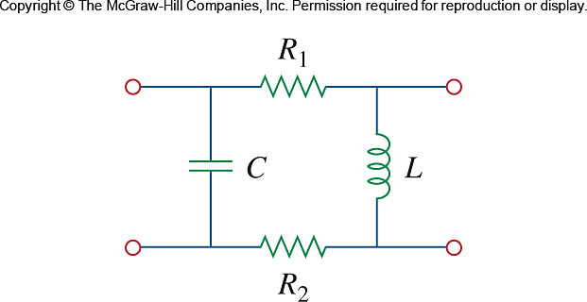
Using Fig. 19.80, design a problem to help other students to better understand how to find y parameters in the s-domain.

Figure 19.80
For Prob. 19.19.

